**Name: Varad Patil**

**Batch: A2**

**Roll no: 120A2036**

**EXPERIMENT NO. 01**

**NUMERICAL APERTURE**

**EXPERIMENT NO. 01**

**NUMERICAL APERTURE**

**OBJECTIVE:**

The objective of this experiment is to determine the numerical aperture of an optical fiber.

**EQUIPMENTS:** Virtual Lab

**FORMULA USED:**

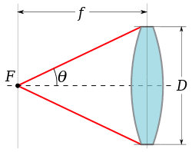



*f* = Focal length

*D=* Diameter



**THEORY:**



Numerical aperture also refers to the maximum angle at which the light incident on the fiber end is totally internally reflected and is properly transmitted along the fiber. Numerical aperture of an optical fiber is defined as the light gathering ability of the fiber.

The light ray should strike the fiber end within this cone of acceptance else it is refracted out of the fiber. Numerically, it is also defined as the sine of the acceptance angle.

It functions as a waveguide, or “light pipe” to transmit light between the two ends of the fiber. An optical fiber is a flexible, transparent fiber made of glass (silica) or plastic, slightly thicker than a human hair. It is surrounded by buffer coating or plastic coating that protects the fiber. Cladding is the outer optical material surrounding the core. Core is a thin glass center of the fiber where light travels.

**PROCEDURE:**

1. Connect one end of the optical fiber cable to the optical source and other end to the numerical aperture jig.
2. Make all the connections. Hold the white screen with four concentric circles (10 mm, 15 mm, 20 mm and 25 mm diameter) vertically at a suitable distance to make the red spot emitted from the optical fiber coincides with the 10 cm circle. Note that the circumference of the spot (outermost) must coincide with the circle.
3. Tabulate the reading and repeat the experiment for 15 mm, 20 mm and 25 mm diameter too where θ is called as the acceptance angle is the maximum angle of incidence at the input end of the optical fiber so that the optical ray can just propagate within the optical fiber.
4. Compute the numerical aperture (NA) of the optical fiber by using the formula Record f, the distance of the screen from the fiber end and note the diameter (D) of the spot.

**OBSERVATION:**

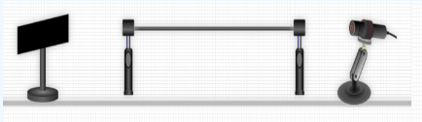

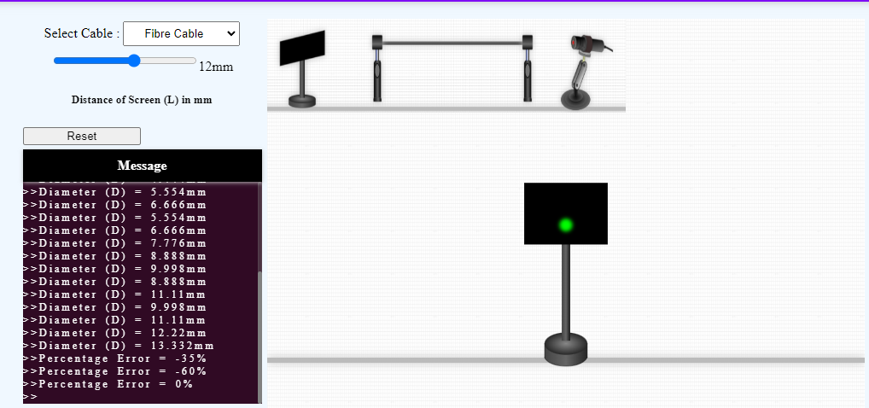

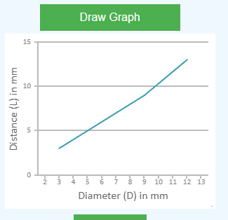

**Refractive index n=**

|  |  |  |  |
| --- | --- | --- | --- |
| Focal length (mm) | Spot Diameter(mm) | Angle θ in degree | NA |
| 3 | 3.332 | 29.05 | 0.485 |
| 6 | 6.666 | 29.05 | 0.485 |
| 9 | 9.998 | 29.05 | 0.485 |
| 12 | 13.332 | 29.05 | 0.485 |

**CONCLUSION:**

**Numerical Aperture is a light gathering ability of fiber. In this Experiment we observe that value of Numerical Aperture remains same as value of L increases, D also increases. Therefore value remains constant i.e. 0% error.**